

TRAINING MATERIAL

ANGULARJS – BASIC
V. 1.0

Last update by: Daniel Panjaitan

WARNING:

This document is intended to be used as internal training material. Distribution outside Geekseat is strictly forbidden.

REVISION HISTORY
Date | Version | Description | Author
25/11/2014 | 0.1 | Document Draft | Alvian Hutahaean
26/11/2014 | 0.2 | Update Document  - View  - Controller  - Scope | Christian Leppong
26/11/2014 | 0.2 | Update Document  - Module | Anova Fawzi
26/11/2014 | 0.2 | Update Document  - AngularJS Architecture | Alvian Hutahaean
26/11/2014 | 0.3 | Update Document  - Scope Part  - Service, Provider, Factory | Christian Leppong
26/11/2014 | 1.0 | Reviewed and Baseline | Daniel Panjaitan

Table of Contents

REVISION HISTORY 3
Table of Contents 4
1. Introduction 6
2. Single Page Application 7
3. Angular SPA 8
3.1. AngularJS Architecture & Conceptual Overview 9
3.2. Setting Environment (Using CDN) 10
4. Directive 11
4.1. Naming The Directive 12
4.2. The Directive Definition Object 12
4.2.1. Restrict 12
4.2.2. Priorities 12
4.2.3. Templates 13
4.2.4. Transclusion 13
4.2.5. Compile and Link Functions 13
4.2.6. Scopes 14
5. Filter 16
6. Views, Controllers and Scope 17
6.1. Views 17
6.2. Controllers 20
6.2.1. Understanding Controller 20
6.2.2. Setting up the initial state of a $scope object 20
6.2.3. Adding Behavior to a Scope Object 21
6.3. Scope 21
7. Modules, Routes and Factories, Services, Providers 25
7.1. Modules 25
7.2. Routes 31
7.2.1. Routes 31
8. Factories , Service , Providers 36
8.1. Factories 37
8.2. Service 40
8.3. Provider 44
Exercise 47
Document References 48

- Introduction
Angular is different in that the template and data get shipped to the browser to be assembled there. The role of the server then becomes only to serve as static resources for the templates and to properly serve the data required by those templates.
AngularJS is a structural framework for dynamic web apps. It lets you use HTML as your template language and lets you extend HTML's syntax to express your application's components clearly and succinctly. Angular's data binding and dependency injection eliminate much of the code you would otherwise have to write. And it all happens within the browser, making it an ideal partner with any server technology.
Angular takes another approach. It attempts to minimize the impedance mismatch between document centric HTML and what an application needs by creating new HTML constructs. Angular teaches the browser new syntax through a construct we call directives. Examples include:
- Data binding, as in {{}}.
- DOM control structures for repeating/hiding DOM fragments.
- Support for forms and form validation.
- Attaching new behavior to DOM elements, such as DOM event handling.
- Grouping of HTML into reusable components.

- Single Page Application
A single-page application (SPA), also known as single-page interface (SPI), is a web application or web site that fits on a single web page with the goal of providing a more fluid user experience akin to a desktop application.
Why do we want to write single page apps? The main reason is that they allow us to offer a more-native-app-like experience to the user. A SPA preloads what the user may most oft use, so when they navigate they are not making network trips and page reloads on those oft used features. Thus the result is a snappy app and a happy user.
Modern single page apps are generally structured as follows:
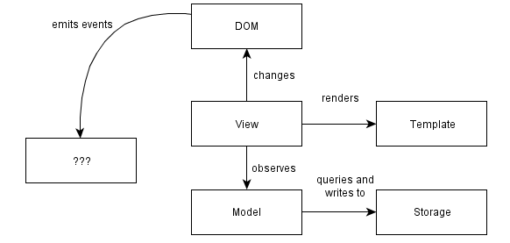
- Write-only DOM. No state / data is read from the DOM. The application outputs HTML and operations on elements, but nothing is ever read from the DOM. Storing state in the DOM gets hard to manage very quickly: it is much better to have one place where the data lives and to render the UI from the data, particularly when the same data has to be shown in multiple places in the UI.
- Models as the single source of truth. Instead of storing data in the DOM or in random objects, there is a set of in-memory models which represent all of the state/data in the application.
- Views observe model changes. We want the views to reflect the content of the models. When multiple views depend on a single model (e.g. when a model changes, redraw these views), we don't want to manually keep track of each dependent view. Instead of manually tracking things, there is a change event system through which views receive change notifications from models and handle redrawing themselves.
- Decoupled modules that expose small external surfaces. Instead of making things global, we should try to create small subsystems that are not interdependent. Dependencies make code hard to set up for testing. Small external surfaces make refactoring internals easy, since most things can changes as long as the external interface remains the same.
- Minimizing DOM dependent-code. Why? Any code that depends on the DOM needs to be tested for cross-browser compatibility. By writing code in a way that isolates those nasty parts, a much more limited surface area needs to be tested for cross-browser compatibility. Cross-browser incompatibilities are a lot more manageable this way. Incompatibilities are in the DOM implementations, not in the JavaScript implementations, so it makes sense to minimize and isolate DOM -dependent code.
- Angular SPA
The Single Page Application is one in which we have a shell page and we can load multiple views into that. So a traditional app, as you know you typically blink and load everything again. It’s not very efficient on the bandwidth, especially in the mobile world. In a SPA we can load the initial content upfront and then the different views or the little kind of mini- web pages can be loaded on the fly and embedded into the shell.
The challenge with building SPAs from scratch is there’s a lot of different issues to deal with: DOM manipulation and history and how do you dynamically load modules and how do you deal with promises when you make async calls and things like that.
Routing becomes a huge issue because you have to have some way to track “Where are we? And where are we going?” Angular is really a full-featured SPA framework.

  - AngularJS Architecture & Conceptual Overview
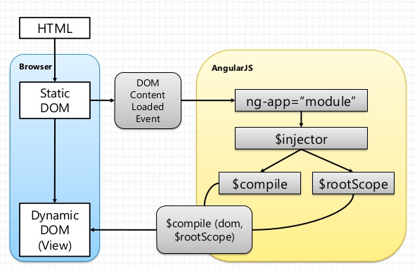
First the HTML is parsed into DOM using the standard browser API. Once all directives for a given DOM element have been identified they are sorted by priority and their directive. The $compile() functions are executed and injected into your code. Register any listeners on the elements and set up any watches with the scope. Live binding between the scope and the DOM.
Models are scope objects in Angular. In traditional MVC, the model encapsulates information to be displayed by a View. Scoping is really just another way of saying, "This is a container for this view."
Notice that the Controller implements the scoped logic. It does the heavy lifting while handing off the results to the Model, which then relays it to the View. You can think of the Model as an interface, whereas the Controller is the implementation of this interface.
Angular breaks down the implementation further to be handled by Services. A service in Angular is implementation logic that would otherwise be in a controller. The purpose of moving this logic out of the controller is to avoid "fat controllers".

  - Setting Environment (Using CDN)
The quickest way to get started is to point your html <script> tag to a Google CDN URL. This way, you don't have to download anything or maintain a local copy.
There are two types of angular script URLs you can point to, one for development and one for production:
- angular.js, this is the human-readable, non-minified version, suitable for web development.
- angular.min.js, this is the minified version, which we strongly suggest you use in production.
To point your code to an angular script on the Google CDN server, use the following template. This example points to the minified version 1.2.0:
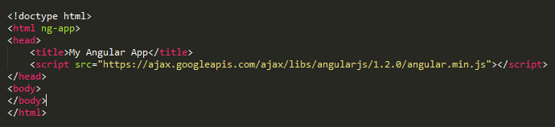

- Directive
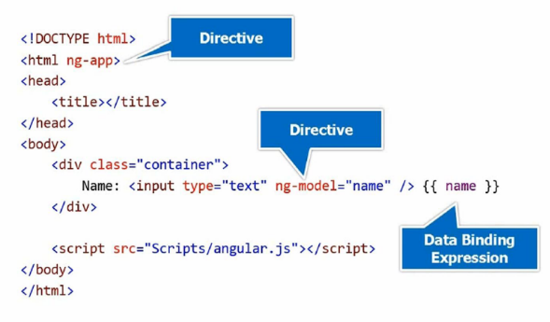
One of the best parts of Angular is that you can write your templates as HTML. You can do this because at the core of the framework we’ve included a powerful DOM transformation engine that lets you extend HTML’s syntax.
Some of the options are mutually exclusive, most of them are optional, and all of them have details that are worth explaining.
Property | Purpose
restrict | Declare how directive can be used in a template as an element, attribute, class, comment, or any combination
priority | Set the order of execution in the template relative to other directives on the element.
template | Specify an inline template as a string. Not used if you’re specifying your template as a URL.
templateUrl | Specify the template to be loaded by URL. This is not used if you’ve specified an inline template as a string.
templateUrl | If true, replace the current element. If false or unspecified, append this directive to the current element.
transclude | Let’s you move the original children of a directive to a location inside the new template.
scope | Create a new scope for this directive rather than inheriting the parent scope.
controller | Create a controller which publishes an API for communicating across directives.
require | Require that another directive be present for this directive to function correctly.
link | Programmatically modify resulting DOM element instances, add event listeners, and set up data binding.
compile | Programmatically modify the DOM template for features across copies of a directive, as when used in ng-repeat.  Your compile function can also return link functions to modify the resulting element instances.
  - Naming The Directive
You create a name for your directive with a module’s directive function, as in the following:
Though you can name your directives anything you like, the convention is to pick a prefix namespace that identifies your directives and prevents them from colliding with external directives that you might include in your project.
Angular uses a normalized naming scheme for directives and will make camel-cased directive names available in templates in the five different validator friendly varieties. For example, if you’ve picked your prefix as super- and you’re writing a date-picker component, you might name it superDatePicker. In templates, you could then use it as super-date-picker, super:date-picker, data-super-date-picker, or another variant.
  - The Directive Definition Object
The Most of the options in the directive definition are optional. In fact, there are no hard requirements and you can construct useful directives out of many subsets of the parameters. Let’s take a walk through what the options do.
    - Restrict
The restrict property lets you specify the declaration style for your directive—that is, whether it can be used as an element name, attribute, class, or comment. You can specify one or more declaration styles using a character to represent each of them
    - Priorities
In cases where you have multiple directives on a single DOM element and where the order in which they’re applied matters, you can use the priority property to order their application. Higher numbers run first. The default priority is 0 if you don’t specify one. Needing to set priority will likely be a rare occurrence. One example of a directive that needs to set priority is the ng-repeat. When repeating elements, we want Angular to make copies of the template element before other directives get applied. Without this, the other directives would get applied to the canonical template element rather than to the repeated elements we want in our app.
    - Templates
When creating components, widgets, controls, and so on, Angular lets you replace or wrap the contents of an element with a template that you provide. Instead of having a bunch of <div>, <ul><li>, and <a> elements, you could create the directives <tab-set> and <tab>, which declare the structure of each tab respectively. Your HTML then does a much better job of expressing the intent of your template.
    - Transclusion
In addition to replacing or appending the content, you can also move the original content within the new template through the transclude property. When set to true, the directive will delete the original content, but make it available for reinsertion within your template through a directive called ng-transclude.
We could change our example to use transclusion:
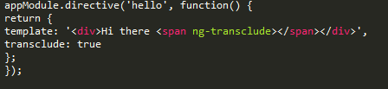
    - Compile and Link Functions
While inserting templates is useful, the really interesting work of any directive happens in its compile or its link function. The compile and link functions are named after the two phases Angular uses to create the live view for your application. Let’s take a high-level view of Angular’s initialization process, in order:
- Script loads
Angular loads and looks for the ng-app directive to find the application boundaries.
- Compile phase
in this phase, Angular walks the DOM to identify all the registered directives in the template. For each directive, it then transforms the DOM based on the directive’s rules (template, replace, transclude, and so on), and calls the compile function if it exists. The result is a compiled template function, which will invoke the link functions collected from all of the directives.
- Link phase
to make the view dynamic, Angular then runs a link function for each directive. The link functions typically creates listeners on the DOM or the model. These listeners keep the view and the model in sync at all times.

Let’s take a look at the syntax for each of these again to compare. For compile, we have:
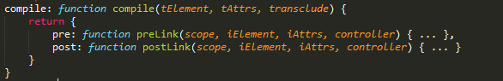
And for link, it is:
Notice that one difference here is that the link function gets access to a scope but compile does not. This is because during the compile phase, the scope doesn’t exist yet. You do, however, have the ability to return link functions from the compile function. These link functions do have access to the scope. Notice also that both compile and link receive a reference to their DOM element and the list of attributes for that element. The difference here is that the compile function receives the template element and attributes from the template, and thus gets the prefix. The link function receives them from the view instances created from the template, and thus gets the i prefix.
    - Scopes
You will often want to access a scope from your directive to watch model values and make UI updates when they change, and to notify Angular when external events cause the model to change. This is most common when you’re wrapping some non-Angular component from jQuery, Closure, or another library, or implementing simple DOM events. Evaluate Angular expressions passed into your directive as attributes. When you want a scope for one of these reasons, you have three options for the type of scope you’ll get:
- The existing scope from your directive’s DOM element.
- A new scope you create that inherits from your enclosing controller’s scope. Here, you’ll have the ability to read all the values in the scopes above this one in the tree. This scope will be shared with any other directives on your DOM element that request this kind of scope and can be used to communicate with them.
- An isolate scope that inherits no model properties from its parent. You’ll want to use this option when you need to isolate the operation of this directive from the parent scope when creating reusable components.
The syntax without aliases is in the following form:
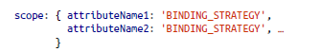
With aliases, the form is:
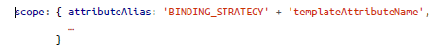
Following is the binding strategies are defined by symbols:
@ | Pass this attribute as a string. You can also data bind values from enclosing scopes by using interpolation {{}} in the attribute value.
= | Data bind this property with a property in your directive’s parent scope.
& | Pass in a function from the parent scope to be called later.
Following is tutorial how to use directive of angular:
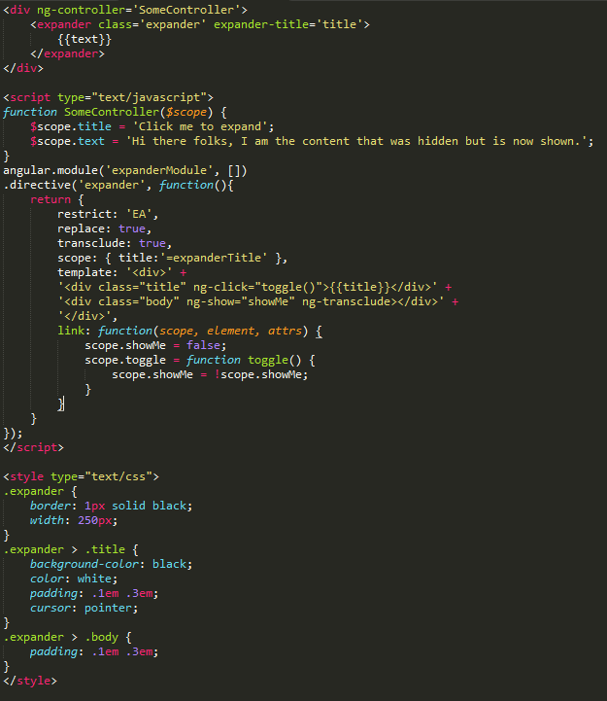

- Filter
Filters allow you to declare how to transform data for display to the user within an interpolation in your template. The syntax for using filters is:
Where expression is any Angular expression, filterName is the name of the filter you want to use, and the parameters to the filter are separated by colons. The parameters themselves can be any valid Angular expression.
Angular comes with several filters, like currency, which we’ve seen:
This bit of code will display the following: $12.90. We put this declaration in the view (rather than in the controller or model) because the dollar sign in front of the number is only important to humans, and not to the logic we use to process the number. Other filters that come with Angular include date, number, uppercase, and more.
Filters can also be chained with additional pipe symbols in the binding. For example, we can format the previous example for no digits after the decimal by adding the number filter, which takes the number of decimals to round to as a parameter. So:
Displays: $13.
You’re not limited to the bundled filters, and it is simple to write your own. If we wanted to create a filter that title-cased strings for our headings, for example, we could do so as follows:
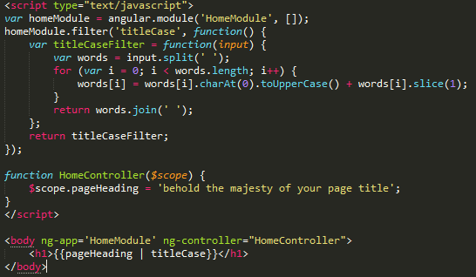

- Views, Controllers and Scope
  - Views
This section is a bit of a hybrid of seemingly unrelated topics, DOM manipulation, $watch, and view services, but they are closely related, as they all live in close proximity around the application's views in implementation.
View basically what the user sees (DOM).
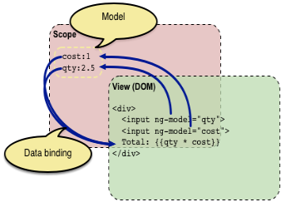
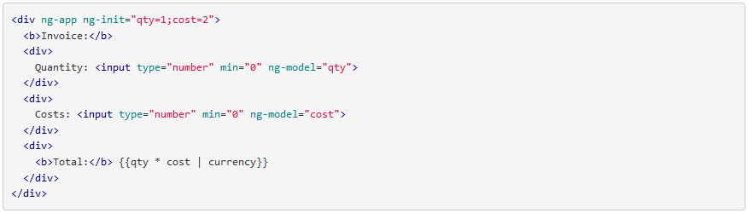
This looks like normal HTML, with some new markup. In Angular, a file like this is called a "template". When Angular starts your application, it parses and processes this new markup from the template using the so-called "compiler". The loaded, transformed and rendered DOM is then called the "view".
The first kind of new markup are the so-called "directives". They apply special behavior to attributes or elements in the HTML. In the example above we use the ng-app attribute, which is linked to a directive that automatically initializes our application. Angular also defines a directive for the input element that adds extra behavior to the element. The ng-model directive stores/updates the value of the input field into/from a variable.

Custom directives to access the DOM: In Angular, the only place where an application should access the DOM is within directives. This is important because artifacts that access the DOM are hard to test. If you need to access the DOM directly you should write a custom directive for this. The directives guide explains how to do this.
Let’s dive in!
The Initial Setup:
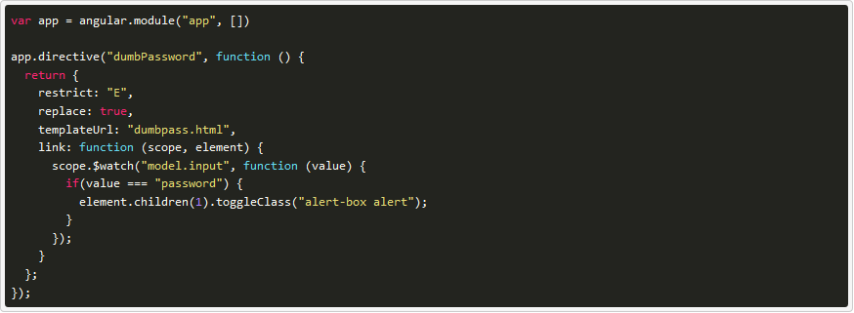
The directive injects the dumbpass.html template to replace the dumb-password element, which is a simple text field bound to model.input, which is echoed in the following div.
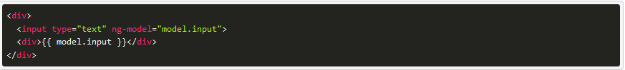
scope.$watch
Invoking scope.$watch on model.input sets a listener on that model and waits for it to change. When it changes, the value parameter can be used to check the new value in the listener function.
This blog post goes into more detail about how watching/listening works.
In our example, the listener checks if model.input is the string "password". If it is, it toggles css classes on element.children(1) using the AngularJS jQuery lite method toggleClass(). element is the top-level entity in the directive, and since here we're replacing the <dumb-password> entity, the top level entity is the first <div> in dumbpass.html, and we care about the 2nd entity in it, thus element.children(1). The traditional methods of locating entities with jQuery selectors are not supported in AngularJS jqLite.</div></dumb-password>
Lets do some refactor!
Since element.children(1) is a brutish way of referencing that entity, we can instead get a reference to the element before it is put on the DOM, via angular.element.
We remove the entity from the template,

angular.element acts as the interface between jQuery/jqLite and AngularJS. The docs on the angular.element API are excellent for furthering understanding. Something to note is that all element references in Angular are always wrapped with jQuery or jqLite; they are never raw DOM references.
Use angular.element to create an element from the string:
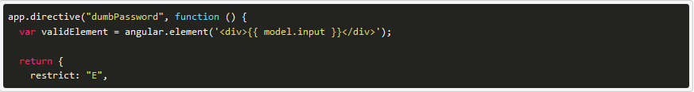
$compile
The compile service takes an HTML string and compiles it into a template function, returning a link function which is used to bind template to a scope. Calling this linking function will then return the element of the template.
With this, the compile function is introduced to append the element:
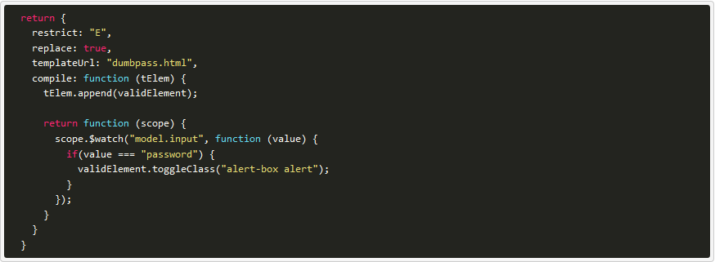
Above, the tElem parameter is the jqLite wrapper of the dumbpass.html template. Since we created the angular.element reference before as a variable in the directive, the tElem jqLite API is used to append the element validElement.
The $compile service returns a link function, which is identical to the previous one except for the fact that we can now reference validElement and use the jqLite API method on it instead of invoking element.children(1).
One last refactor that can be made is to move the link function into a directive variable, which is a bit cleaner. The final main.js is as follows:
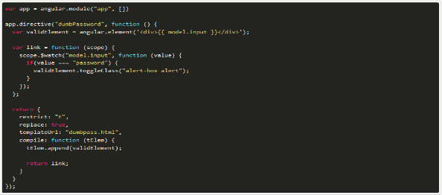
  - Controllers
    - Understanding Controller
In Angular, a Controller is a JavaScript constructor function that is used to augment the Angular Scope.
When a Controller is attached to the DOM via the ng-controller directive, Angular will instantiate a new Controller object, using the specified Controller's constructor function. A new child scope will be available as an injectable parameter to the Controller's constructor function as $scope.
Use controllers to:
- Set up the initial state of the $scope object.
- Add behavior to the $scope object.
Do not use controllers to:
- Manipulate DOM — Controllers should contain only business logic. Putting any presentation logic into Controllers significantly affects its testability. Angular has databinding for most cases and directives to encapsulate manual DOM manipulation.
- Format input — Use angular form controls instead.
- Filter output — Use angular filters instead.
- Share code or state across controllers — Use angular services instead.
- Manage the life-cycle of other components (for example, to create service instances).
    - Setting up the initial state of a $scope object
Typically, when you create an application you need to set up the initial state for the Angular $scope. You set up the initial state of a scope by attaching properties to the $scope object. The properties contain the view model (the model that will be presented by the view). All the $scope properties will be available to the template at the point in the DOM where the Controller is registered.
The following example demonstrates creating a GreetingController, which attaches a greeting property containing the string 'Hola!' to the $scope:
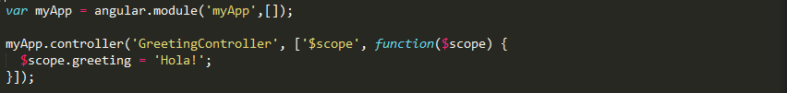
We create an Angular Module, myApp, for our application. Then we add the controller's constructor function to the module using the .controller() method. This keeps the controller's constructor function out of the global scope.
We have used an inline injection annotation to explicitly specify the dependency of the Controller on the $scope service provided by Angular. See the guide on Dependency Injection for more information.

We attach our controller to the DOM using the ng-controller directive. The greeting property can now be data-bound to the template:
    - Adding Behavior to a Scope Object
In order to react to events or execute computation in the view we must provide behavior to the scope. We add behavior to the scope by attaching methods to the $scope object. These methods are then available to be called from the template/view.
The following example uses a Controller to add a method to the scope, which doubles a number:
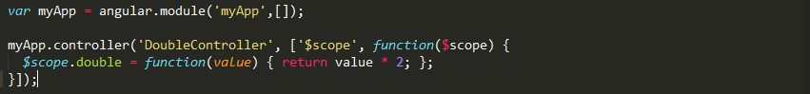
Once the Controller has been attached to the DOM, the double method can be invoked in an Angular expression in the template:
Any objects (or primitives) assigned to the scope become model properties. Any methods assigned to the scope are available in the template/view, and can be invoked via angular expressions and ng event handler directives (e.g. ngClick).
In general, a Controller shouldn't try to do too much. It should contain only the business logic needed for a single view. The most common way to keep Controllers slim is by encapsulating work that doesn't belong to controllers into services and then using these services in Controllers via dependency injection. You may check Dependency Injection Services sections.
  - Scope
A $scope is an object that ties a view (a DOM element) to the controller. In the Model-View-Controller structure, this $scope object becomes the model. It provides an execution context that is bound to the DOM element (and its children).
The glue between the View and the Controller is something called the Scope, and in Angular you’re going to see a lot of objects or variables that start with $. $scope represents the scope object.
The view doesn’t have to know about the controller, and the controller definitely doesn’t want to know about the view.
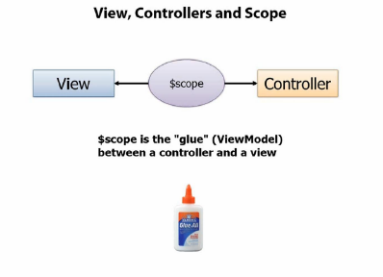
Although it sounds complex, the $scope is just a JavaScript object. Both the controller and the view have access to the $scope so it can be used for communication between the two. This $scope object will house both the data and the functions that we’ll want to run in the view, as we’ll see.
All AngularJS apps have a $rootScope. The $rootScope is the top-most scope that is created on the DOM element that contains the ng-app directive.
In this example, we’re working with the $rootScope. We add an attribute on the scope of name in our main.js file. By putting this function in the app.run function, we’ll guarantee that it will run prior to the rest of the app. You can think of the run function being the main method of the angular app.
Now, anywhere in our view, we can reference this attribute using the expression/template: {{ }}, like so:
In summary:
- Anything that we attach to this $scope object will become available to the view.
- Likewise, any changes that the controller makes to the model will show up as changes in the view.
To really see the power of scopes, let’s attach a controller to a DOM element, which will create a $scope for the element and allow us to interact with it.

Using scope with controller
To explicitly create a $scope object, we’ll attach a controller object to a DOM element using the ng-controller directive on an object, like so:
The ng-controller directive creates a new $scope object for the DOM element and nests it in the containing $scope. In this example, the parent $scope of the div with ng-controller is the $rootScope object. The scope chain looks like this:
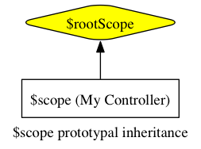
Now, MyController sets up a $scope that we can access from inside the DOM element. In this case, we’re going to create a person object on the $scope of MyController, in main.js:
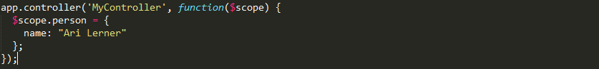
Now we can access this person object in any child element of the div where ng-controller='MyController' is written because it is on the $scope.
With one exception, all scopes are created with prototypal inheritance, meaning that they have access to their parent scopes. By default, for any property that AngularJS cannot find on a local scope, AngularJS will crawl up to the containing (parent) scope and look for the property or method there. If AngularJS can’t find the property there, it will walk to that scope’s parent and so on and so forth until it reaches the $rootScope.
The one exception: Some directives can optionally create an isolate scope and do not inherit from their parents.
For instance, say we have a ParentController that contains the person object and a ChildController that wants to reference that object:
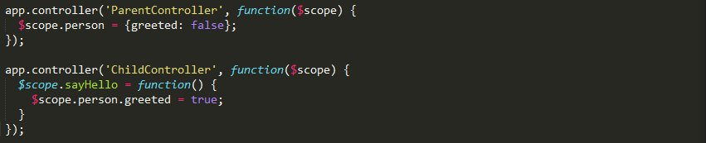
When we bind the ChildController under the ParentController in our view, we can reference the property on the parent scope just as if it were on the ChildController:
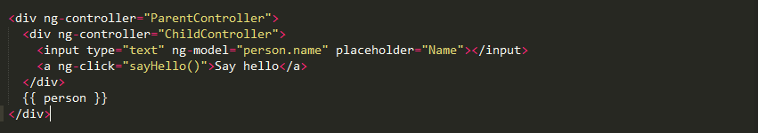

- Modules, Routes and Factories, Services, Providers
  - Modules
What is a Module?
You can think of a module as a container for the different parts of your app – controllers, services, filters, directives, etc.
Most applications have a main method that instantiates and wires together the different parts of the application.
Angular apps don't have a main method. Instead modules declaratively specify how an application should be bootstrapped. There are several advantages to this approach:
- The declarative process is easier to understand.
- You can package code as reusable modules.
- The modules can be loaded in any order (or even in parallel) because modules delay execution.
- Unit tests only have to load relevant modules, which keeps them fast.
- End-to-end tests can use modules to override configuration.
Let see this diagram:
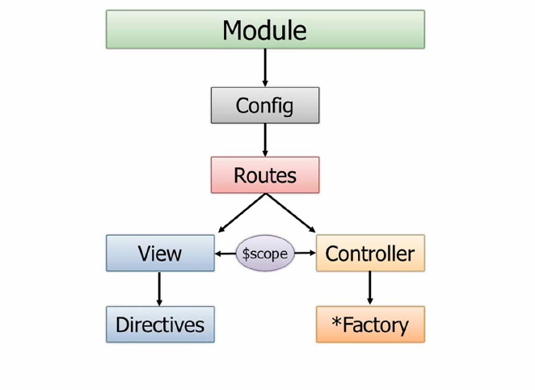
So a module can have something off of it called a config function, and it can be defined to use different routes. Now routes again are really important in the SPA world because if you have different views and those views need to be loaded into the shell page then we need a way to be able to track what route we’re on and what view that’s associated with and then what controller goes with that view and how we do all of that marrying together of these different pieces.
When you define a route in AngularJS you can define two things on that route – two of the key things, I should say.
One of those is the view. So what view when that route such as “unit.org/orders” then maybe go to “orderspartial.html” or “ordersfragment.html” or whatever you want to call it.
Then that view needs a controller. Instead of hard-coding the controller into the view – which works and you can certainly do it: I showed that in the previous section – we can actually go in and do this on our own through the route.
A given controller would then of course have access to the scope object which then the view will bind to. I talked about that a little bit earlier.
And then controllers rather than having all the functionality to get the data and update the data and perform CRUD operations and things like that, in a more real life application they’ll call out to factories or… I put a star there because you might have services, providers or even values you want to get. There are a lot of different ways you can access data. Even resources.
On the views we of course then have directives and filters and those types of things.
There’s even more to the overall picture but this is one of those things I wish I would’ve seen this right upfront because I would have kind of instantly had that light bulb moment where the light goes on and you say “OK. So you define a route, a route has a controller and a view and then the controller can load data from factories and services and things.”
Modules are containers
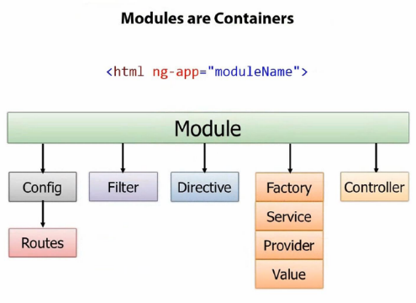
There is a module object and I’ll show you how to create that – you literally just say angular.module – and off of the module you can configure the routes, create custom filters, custom directives. You can get data from different sources using Factories, Services, Providers or Values. You can then even create Controllers using the module. You can think of the module as really just an object container, and then in that container you can have all these different things that you see here.
What’s important is that once the module is given a name that’s when you’re going to go into ng-app and whatever the module name is that’s what’s going to go here. So they could have just as easily called it ng-module, but I actually like ng-app – it makes sense I think.
The Basics
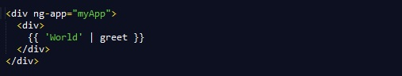
Important things to notice:
- The Module API
- The reference to myApp module in <div ng-app="myApp">. This is what bootstraps the app using your module.
- The empty array in angular.module('myApp', []). This array is the list of modules myApp depends on.

Recommended Setup
While the example above is simple, it will not scale to large applications. Instead we recommend that you break your application to multiple modules like this:
- A module for each feature
- A module for each reusable component (especially directives and filters)
- And an application level module which depends on the above modules and contains any initialization code.
This is the simplest example on modularize your angular application.
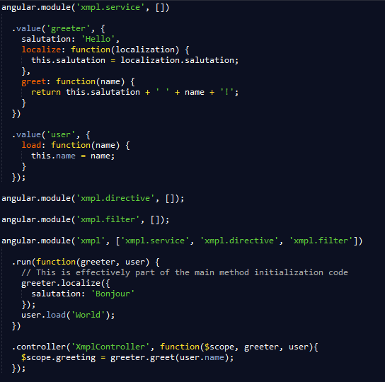
And now we try to use the module.
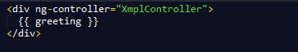
As we see.
Module Loading & Dependencies
A module is a collection of configuration and run blocks which get applied to the application during the bootstrap process. In its simplest form the module consist of a collection of two kinds of blocks:
- Configuration blocks - get executed during the provider registrations and configuration phase. Only providers and constants can be injected into configuration blocks. This is to prevent accidental instantiation of services before they have been fully configured.
- Run blocks - get executed after the injector is created and are used to kickstart the application. Only instances and constants can be injected into run blocks. This is to prevent further system configuration during application run time.
Here is an illustration to make it easier to understand.
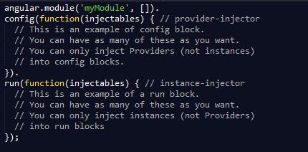
Configuration Blocks
There are some convenience methods on the module which are equivalent to the config block. For example:
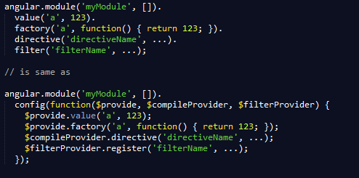
Run Blocks
Run blocks are the closest thing in Angular to the main method. A run block is the code which needs to run to kick start the application. It is executed after all of the service have been configured and the injector has been created. Run blocks typically contain code which is hard to unit-test, and for this reason should be declared in isolated modules, so that they can be ignored in the unit-tests.
Dependencies
Modules can list other modules as their dependencies. Depending on a module implies that required module needs to be loaded before the requiring module is loaded. In other words the configuration blocks of the required modules execute before the configuration blocks of the requiring module. The same is true for the run blocks. Each module can only be loaded once, even if multiple other modules require it.
Asynchronous Loading
Modules are a way of managing $injector configuration, and have nothing to do with loading of scripts into a VM. There are existing projects which deal with script loading, which may be used with Angular. Because modules do nothing at load time they can be loaded into the VM in any order and thus script loaders can take advantage of this property and parallelize the loading process.
Creation versus Retrieval
Beware that using angular.module('myModule', []) will create the module myModule and overwrite any existing module named myModule. Use angular.module('myModule') to retrieve an existing module.
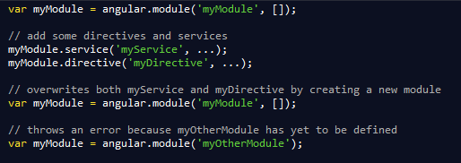
Unit Testing
A unit test is a way of instantiating a subset of an application to apply stimulus to it. Small, structured modules help keep unit tests concise and focused.
Each module can only be loaded once per injector. Usually an Angular app has only one injector and modules are only loaded once. Each test has its own injector and modules are loaded multiple times.
In all of these examples we are going to assume this module definition:
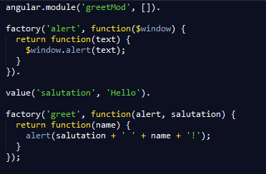

Let's write some tests to show how to override configuration in tests.
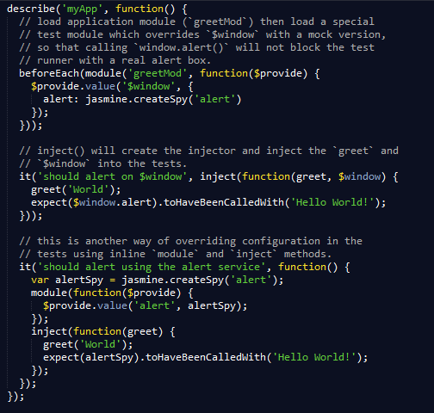
  - Routes
    - Routes
AngularJS routes enable you to create different URLs for different content in your application. Having different URLs for different content enables the user to bookmark URLs to specific content, and send those URLs to friends etc. In AngularJS each such bookmarkable URL is called a route.
AngularJS routes enables you to show different content depending on what route is chosen. A route is specified in the URL after the # sign. Thus, the following URL's all point to the same AngularJS application, but each point to different routes:
- http://myangularjsapp.com/index.html#books
- http://myangularjsapp.com/index.html#albums
- http://myangularjsapp.com/index.html#games
- http://myangularjsapp.com/index.html#apps
When the browser loads these links, the same AngularJS application will be loaded (located at http://myangularjsapp.com/index.html), but AngularJS will look at the route (the part of the URL after the #) and decide what HTML template to show.
At this point it may sound a little abstract, so let us look at a fully working AngularJS route example:
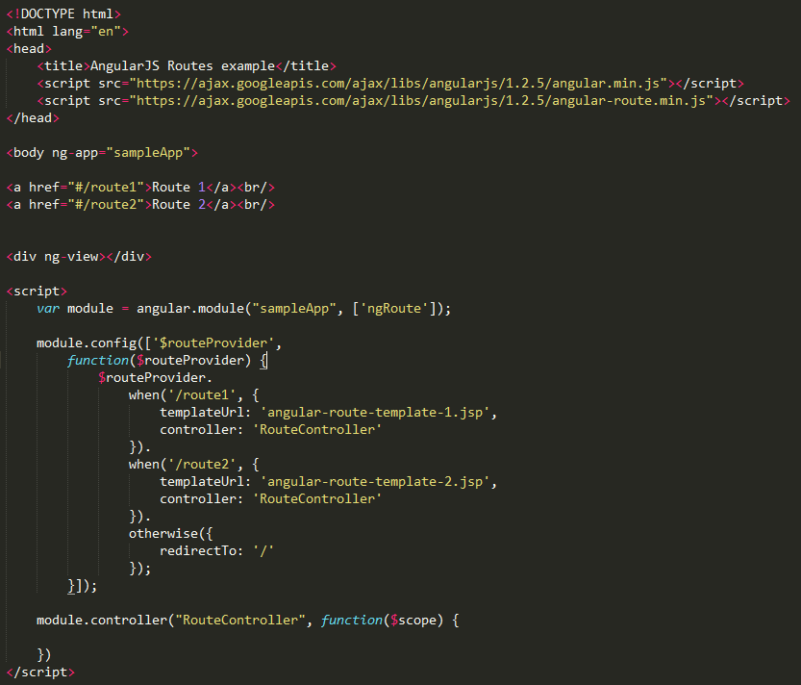

Each part of this sample application will be explained in the following sections.
Including the AngularJS Route Module
The first thing to notice in the example application above is the extra JavaScript included inside the head section:
The AngularJS Route module is contained in its own JavaScript file. To use it we must include in our AngularJS application.
Declaring a Dependency on the AngularJS Route Module
The second thing to notice is that the applications's AngularJS module (called sampleApp) declares a dependency on the AngularJS route module:
The application's module needs to declare this dependency in order to use the ngRoute module.
The ngView Directive
The third thing to notice in the example above is the use of the ngView directive:
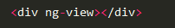
Inside the div with the ngView directive (can also be written ng-view) the HTML template specific to the given route will be displayed.
Configuring the $routeProvider
The fourth thing to notice in the example shown at the beginning of this text is the configuration of the $routeProvider. The $routeProvider is what creates the $route service. By configuring the $routeProvider before the $route service is created we can set what routes should result in what HTML templates being displayed.
Here is the code from the example:
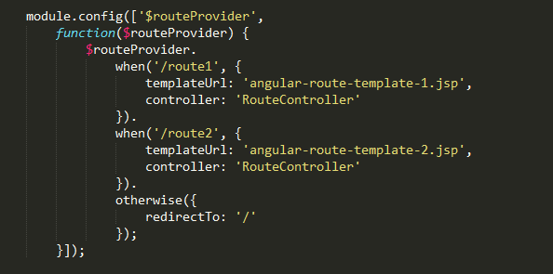
The $routeProvider is configured in the module's config() function. We pass a configuration function to the module's config() function which takes the $routeProvider as parameter. Inside this function we can now configure the $routeProvider.
The $routeProvider is configured via calls to the when() and otherwise() functions.
The when() function takes a route path and a JavaScript object as parameters.
The route path is matched against the part of the URL after the # when the application is loaded. As you can see, the two route paths passed to the two when() function calls match the two route paths in the href attribute of the links in the same example.
The JavaScript object contains two properties named templateUrl and controller. The templateUrl property tells which HTML template AngularJS should load and display inside the div with the ngView directive. The controller property tells which of your controller functions that should be used with the HTML template.
The otherwise() function takes a JavaScript object. This JavaScript object tells AngularJS what it should do if no route paths matches the given URL. In the example above the browser is redirected to the same URL with #/ as route path.
Links to Routes
The final thing to notice in this example is the two links in the HTML page:
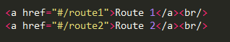
Notice how the part of the URLs after the # matches the routes configured on the $routeProvider.
When one of these links is clicked, the URL in the browser window changes, and the div with the ngView directive will show the HTML template matching the route path.
Route Parameters
You can embed parameters into the route path. Here is an AngularJS route path parameter example:
This is a URL with a route path in. In fact it pretty much consists of just the route path. The parameter part is the 12345 which is the specific id of the book the URL points to.
AngularJS can extract values from the route path if we define parameters in the route paths when we configure the $routeProvider. Here is the example $routeProvider from earlier, but with parameters inserted into the route paths:
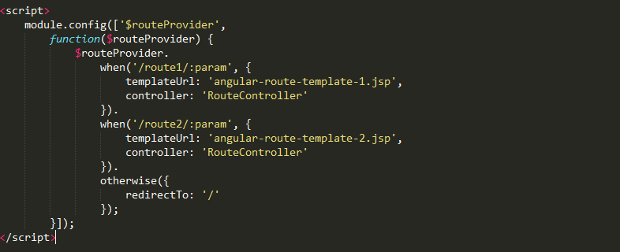
Both of the URLs in the when() calls now define a parameter. It is the part starting from the colon (:param)
AngularJS will now extract from the URL (route path) whatever comes after the #/route1/ part. Thus, from this URL:
The value 12345 will be extracted as parameter.
Your controller functions can get access to route parameters via the AngularJS $routeParams service like this:
Notice how the controller function takes the $routeParams service as parameter, and then copies the parameter named param into the $scope.param property. Now your AngularJS views can get access to it, or you can use it in AJAX calls etc.
Here is a full AngularJS route parameter example:
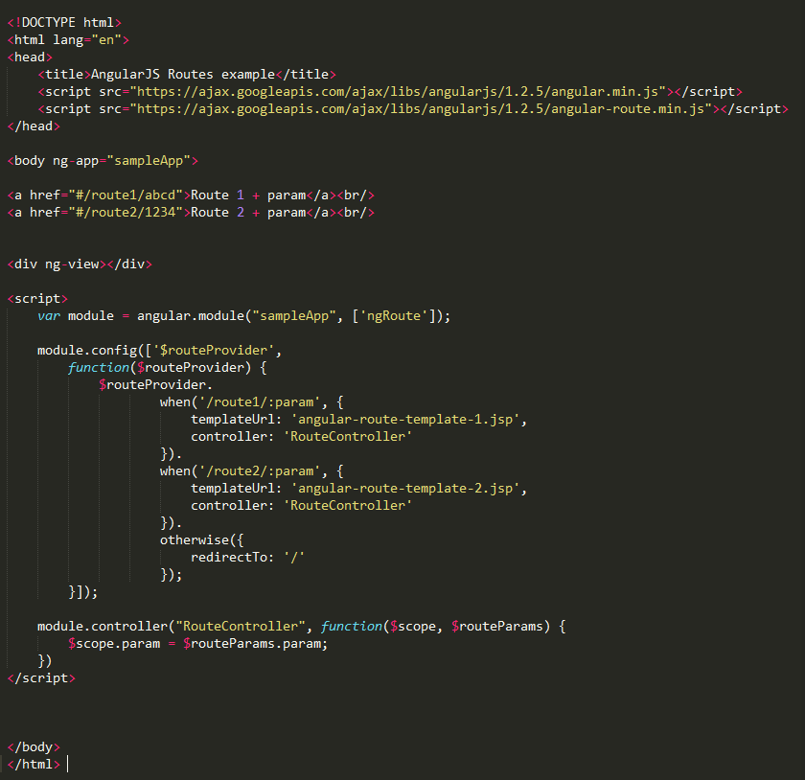
- Factories , Service , Providers
Now that you’ve seen how to create modules and how modules can then be used to define routes and also to work with controllers, we’re going to wrap up by talking about some re-use concepts.
Another feature of AngularJS is the ability to encapsulate data functionality into factory, services, provider or little value providers.
We are going to focus on factories here but all three of the top ones shown here – factory, service and providers – they allow us to encapsulate common functionality.
So for instance if I had to go and get customers and I need those customers in multiple controllers I wouldn’t want to hard code that data in each controller. It just wouldn’t make sense and there’d be a lot of duplication there.
Instead what I’ll do is I’ll move that code out to a factory, service or provider.

The difference between the three is just the way in which they create the object that goes and gets the data. That’s really all there is to it.
- With the factory you actually create an object inside of the factory and return it.
- With the service you just have a standard function that uses the this keyword to define function.
- With the provider there’s a $get you define and it can be used to get the object that returns the data.

Factory vs service vs provider explained
When you’re using a Factory you create an object, add properties to it, then return that same object. When you pass this service into your controller, those properties on the object will now be available in that controller through your factory.
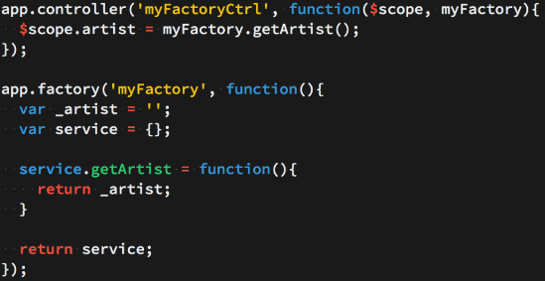

When you’re using Service, it’s instantiated with the ‘new’ keyword. Because of that, you’ll add properties to ‘this’ and the service will return ‘this’. When you pass the service into your controller, those properties on ‘this’ will now be available on that controller through your service.
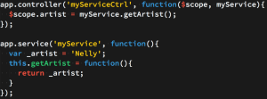

Providers are the only service you can pass into your .config() function. Use a provider when you want to provide module-wide configuration for your service object before making it available.
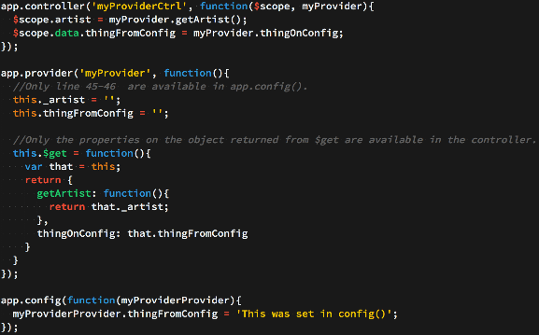
In order to extensively show the difference between a Factory, Service, and Provider, we’re going to build the same service in three separate ways. The services are going to utilize the iTunes API as well as promises with $q.
  - Factories
Factories are the most popular way to create and configure a service. You just create an object, add properties to it, then return that same object. Then when you pass the factory into your controller, those properties on the object will now be available in that controller through your factory. A more extensive example is below.
First we create an object, then return that object like so.
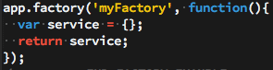
Now whatever properties we attach to ‘service’ will be available to us when we pass ‘myFactory’ into our controller.
Now let’s add some ‘private’ variables to our callback function. These won’t be directly accessible from the controller, but we will eventually set up some getter/setter methods on ‘service’ to be able to alter these ‘private’ variables when needed.
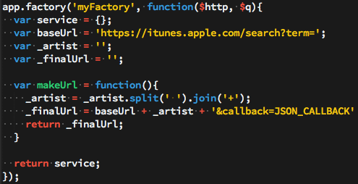
Here you’ll notice we’re not attaching those variables/function to ‘service’. We’re simply creating them in order to either use or modify them later.
- baseUrl is the base URL that the iTunes API requires
- _artist is the artist we wish to lookup
- _finalUrl is the final and fully built URL to which we’ll make the call to iTunes
- makeUrl is a function that will create and return our iTunes friendly URL.
Now that our helper/private variables and function are in place, let’s add some properties to the ‘service’ object. Whatever we put on ‘service’ we’ll be able to directly use in whichever controller we pass ‘myFactory’ into.
We are going to create setArtist and getArtist methods that simply return or set the artist. We are also going to create a method that will call the iTunes API with our created URL. This method is going to return a promise that will fulfill once the data has come back from the iTunes API. If you haven’t had much experience using promises in Angular, I highly recommend doing a deep dive on them.
- setArtist accepts an artist and allows you to set the artist
- getArtist returns the artist
- callItunes first calls makeUrl() in order to build the URL we’ll use with our $http request. Then it sets up a promise object, makes an $http request with our final url, then because $http returns a promise, we are able to call .success or .error after our request. We then resolve our promise with the iTunes data, or we reject it with a message saying ‘There was an error’.
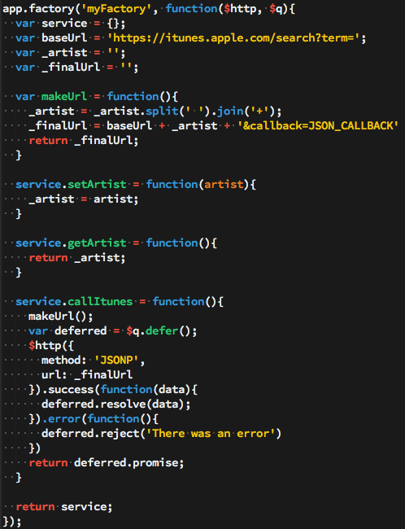

Now our factory is complete. We are now able to inject ‘myFactory’ into any controller and we’ll then be able to call our methods that we attached to our service object (setArtist, getArtist, and callItunes).
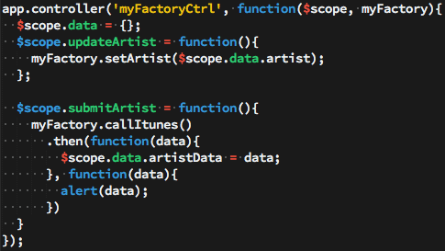

In the controller above we’re injecting in the ‘myFactory’ service. We then set properties on our $scope object that are coming from data from ‘myFactory’. The only tricky code above is if you’ve never dealt with promises before. Because callItunes is returning a promise, we are able to use the .then() method and only set $scope.data.artistData once our promise is fulfilled with the iTunes data. You’ll notice our controller is very ‘thin’. All of our logic and persistent data is located in our service, not in our controller.
  - Service
Perhaps the biggest thing to know when dealing with creating a Service is that that it’s instantiated with the ‘new’ keyword. For you JavaScript gurus this should give you a big hint into the nature of the code. For those of you with a limited background in JavaScript or for those who aren’t too familiar with what the ‘new’ keyword actually does, let’s review some JavaScript fundamentals that will eventually help us in understanding the nature of a Service.
To really see the changes that occur when you invoke a function with the ‘new’ keyword, let’s create a function and invoke it with the ‘new’ keyword, then let’s show what the interpreter does when it sees the ‘new’ keyword. The end results will both be the same.
First let’s create our Constructor.
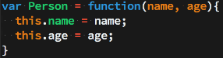
This is a typical JavaScript constructor function. Now whenever we invoke the Person function using the ‘new’ keyword, ‘this’ will be bound to the newly created object.
Now let’s add a method onto our Person’s prototype so it will be available on every instance of our Person ‘class’.
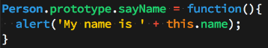
Now, because we put the sayName function on the prototype, every instance of Person will be able to call the sayName function in order alert that instance’s name.
Now that we have our Person constructor function and our sayName function on its prototype, let’s actually create an instance of Person then call the sayName function.
So all together the code for creating a Person constructor, adding a function to it’s prototype, creating a Person instance, and then calling the function on its prototype looks like this.
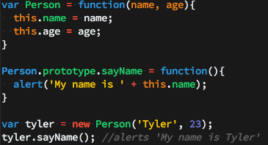
Now let’s look at what actually is happening when you use the ‘new’ keyword in JavaScript. First thing you should notice is that after using ‘new’ in our example, we’re able to call a method (sayName) on ‘tyler’ just as if it were an object – that’s because it is. So first, we know that our Person constructor is returning an object, whether we can see that in the code or not. Second, we know that because our sayName function is located on the prototype and not directly on the Person instance, the object that the Person function is returning must be delegating to its prototype on failed lookups. In more simple terms, when we call tyler.sayName() the interpreter says “OK, I’m going to look on the ‘tyler’ object we just created, locate the sayName function, then call it. Wait a minute, I don’t see it here – all I see is name and age, let me check the prototype. Yup, looks like it’s on the prototype, let me call it.”.
Below is code for how you can think about what the ‘new’ keyword is actually doing in JavaScript. It’s basically a code example of the above paragraph. I’ve put the ‘interpreter view’ or the way the interpreter sees the code inside of notes.
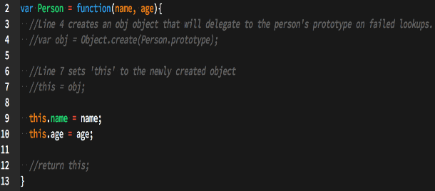
Now having this knowledge of what the ‘new’ keyword really does in JavaScript, creating a Service in Angular should be easier to understand now.
The biggest thing to understand when creating a Service is knowing that Services are instantiated with the ‘new’ keyword. Combining that knowledge with our examples above, you should now recognize that you’ll be attaching your properties and methods directly to ‘this’ which will then be returned from the Service itself. Let’s take a look at this in action.
Unlike what we originally did with the Factory example, we don’t need to create an object then return that object because, like mentioned many times before, we used the ‘new’ keyword so the interpreter will create that object, have it delegate to its prototype, then return it for us without us having to do the work.
First things first, let’s create our ‘private’ and helper function. This should look very familiar since we did the exact same thing with our factory. I won’t explain what each line does here because I did that in the factory example, if you’re confused, re-read the factory example.
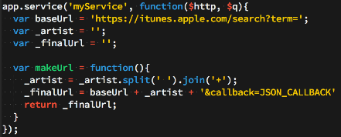
Now, we’ll attach all of our methods that will be available in our controller to ‘this’.
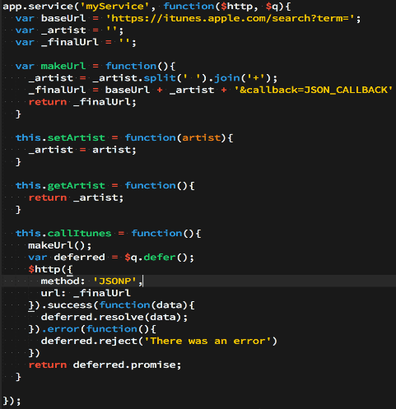
Now just like in our factory, setArtist, getArtist, and callItunes will be available in whichever controller we pass myService into. Here’s the myService controller (which is almost exactly the same as our factory controller).
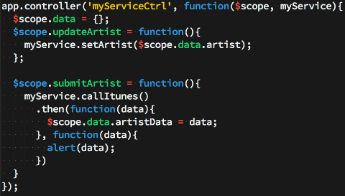
Like I mentioned before, once you really understand what ‘new’ does, Services are almost identical to factories in Angular.

  - Provider
The biggest thing to remember about Providers is that they’re the only service that you can pass into the app.config portion of your application. This is of huge importance if you’re needing to alter some portion of your service object before it’s available everywhere else in your application. Although very similar to Services/Factories, there are a few differences which we’ll discuss.
First we set up our Provider in a similar way we did with our Service and Factory. The variables below are our ‘private’ and helper function.
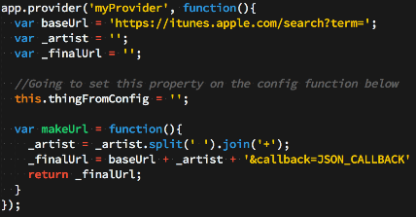

You can think of Providers as having three sections. The first section is the ‘private’ variables/functions that will be modified/set later (shown above). The second section is the variables/functions that will be available in your app.config function and are therefore available to alter before they’re available anywhere else (also shown above). It’s important to note that those variables need to be attached to the ‘this’ keyword. In our example, only ‘thingFromConfig’ will be available to alter in the app.config. The third section (shown below) is all the variables/functions that will be available in your controller when you pass in the ‘myProvider’ service into that specific controller.
When creating a service with Provider, the only properties/methods that will be available in your controller are those properties/methods which are returned from the $get() function. The code below puts $get on ‘this’ (which we know will eventually be returned from that function). Now, that $get function returns all the methods/properties we want to be available in the controller. Here’s a code example.
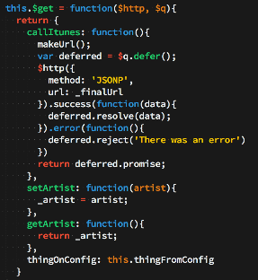
Now the full Provider code looks like this
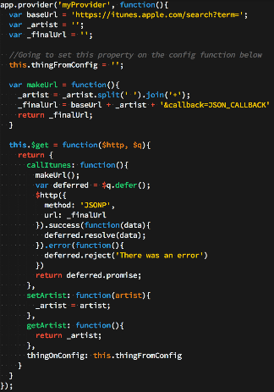
Now just like in our factory and Service, setArtist, getArtist, and callItunes will be available in whichever controller we pass myProvider into. Here’s the myProvider controller (which is almost exactly the same as our factory/Service controller).
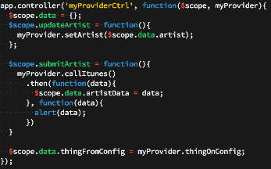
As mentioned before, the whole point of creating a service with Provider is to be able to alter some variables through the app.config function before the final object is passed to the rest of the application. Let’s see an example of that.
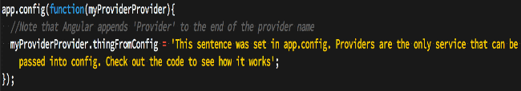
Now you can see how ‘thingFromConfig’ is as empty string in our provider, but when that shows up in the DOM, it will be ‘This sentence was set…’.

Exercise
- Create a simple SPA application using angular with following description.
- User information contains : user name, name, address, age, gender, salary and job
- Create array of user information.
- Display all user information.
- Display detail user information
- Form Login
- Required validation for username and password in form login
- After doing login, will redirect to display all user information
- Please use directive to display user information and filter to convert salary using rupiah symbol

- Please try every tutorials at this site : https://thinkster.io/angulartutorial/a-better-way-to-learn-angularjs/

Document References
- http://www.slideshare.net/EyalV/angularjs-architecture
- http://backstopmedia.booktype.pro/angularjs-book/chapter-2-six-core-concepts/
- https://thinkster.io/angulartutorial/a-better-way-to-learn-angularjs/
- https://docs.angularjs.org/guide/concepts
- Wahlin, Dan. (2013). AngularJS in 60 Minutes

